# Computer Graphics (UCS505)

# Project on

# SKY DANCE

**(AN AIR SHOW ANIMATION)**

**Submitted By:**

Pulkit Arora 102103267

Sehajbir Singh Bains 102103290

Geet Inder Singh Sodhi 102103292

# 3CO10 (Group 11)

**B.E. Third Year – COE**

**Submitted To:**

**KUNTAL CHOWDHURY**



**Computer Science and Engineering Department Thapar Institute of Engineering and Technology Patiala – 147001**

**Table of Contents**

|  |  |  |
| --- | --- | --- |
| **Sr. No.** | **Description** | **Page No.** |
| 1. | Introduction to Project | 3 |
| 2. | Computer Graphics concepts used | 4 |
| 3. | User Defined Functions | 5 |
| 4. | Code | 7 |
| 5. | Output/ Screen shots | 25 |

**INTRODUCTION TO PROJECT**

* Welcome to "Skydance"! Get ready to embark on an exciting journey into the world of aviation, where you'll witness jaw-dropping air shows filled with stunning planes and thrilling maneuvers. Our project is all about bringing the thrill of flying to life through amazing visuals and cool animations.
* In "Skydance," you'll see all sorts of airplanes, from sleek jets to classic biplanes and even helicopters. They're all designed to look just like the real thing, so you'll feel like you're right there in the cockpit. And the sounds? They're just as awesome, with roaring engines and spinning propellers making you feel like you're really at an air show.
* But "Skydance" isn't just about the planes—it's also a tribute to the amazing pilots who fly them. Watch as they pull off incredible stunts and mind-blowing tricks with perfect timing and skill. Whether they're flying solo or performing as part of a team, every pilot in "Skydance" is a true master of the sky.
* As you watch the planes zoom and loop through the air, you'll also learn all about the history of flight and the cool technology that makes it possible. From the very first airplanes built by the Wright brothers to the high-tech jets of today, "Skydance" will take you on a fascinating journey through the past, present, and future of aviation.
* Whether you're a big aviation fan, a curious learner, or just someone who loves awesome animations, "Skydance" has something for you. So buckle up, hold on tight, and get ready to soar through the clouds with "Skydance"! It's going to be an epic adventure you won't forget. Welcome aboard!

**COMPUTER GRAPHICS CONCEPTS**

In the creation of "Skydance," several fundamental computer graphics concepts were employed to bring the aviation world to life with stunning visuals and engaging animations. Here are some of the key concepts utilized in the project:

1. **3D Modeling:** "Skydance" utilizes 3D modeling to create lifelike representations of airplanes, helicopters, and other objects in the aviation environment. Each aircraft is meticulously designed with accurate proportions, textures, and details to enhance realism and immersion.
2. **Texturing:** Texturing is applied to the 3D models to enhance their appearance by adding surface details such as colors, patterns, and materials. In "Skydance," texturing is used to simulate the metallic sheen of airplane bodies, the glossy finish of cockpit canopies, and the intricate designs of aircraft liveries.
3. **Animation:** Animation plays a crucial role in bringing the aircraft and airshow performances to life in "Skydance." Through techniques such as keyframing and rigging, the planes perform dynamic maneuvers such as loops, rolls, and spins, while the pilots execute precise aerobatic routines with fluid motion and timing.
4. **Lighting and Shading:** Lighting and shading techniques are used to create realistic illumination and shadow effects in "Skydance." Dynamic lighting sources such as the sun and stadium floodlights cast shadows and highlights on the aircraft and environment, enhancing depth perception and visual fidelity.
5. **Rendering:** Rendering is the process of generating the final images or frames from the 3D scene. In "Skydance," rendering techniques such as ray tracing or rasterization are employed to produce high-quality visuals with realistic reflections, shadows, and atmospheric effects, ensuring an immersive viewing experience for the audience.
6. **Transformation:** Transformation concepts, including translation, rotation, and scaling, are integral to positioning and orienting objects within the 3D space of "Skydance." These transformations enable the choreography of aerial maneuvers, the movement of camera perspectives, and the placement of objects throughout the scene, enhancing the overall dynamism and realism of the virtual environment.

**USER DEFINED FUNCTIONS**

Here is a list of all the user-defined functions used in this project :

* **output(int x, int y, char *string,void *font) :** This function is used to render text on the screen at a specified position.
* **sphere(float r, float g, float b, float a) : Draws** a solid sphere with the specified color and transparency.
* **smoke(float size, float alpha, float R, float G, float B)** : Draws a smoke particle with the specified size, transparency, and color.
* **drawSmoke(float R, float G, float B, float x, float y, int reflect) :** Draws a collection of smoke particles with varying positions, sizes, and transparencies.
* **slab(float r, float g, float b) :** Draws a solid cube with the specified color.
* **bridge() :** Draws a bridge structure using cubes to simulate its components.
* **ground() :** Draws the ground with different colored polygons to represent terrain.
* **wing(int Colour) :** Draws an airplane wing with specified color and geometry.
* **fin(int Colour) :** Draws the fin of an airplane with specified color and geometry.
* **plane(int Colour) :** Draws an airplane with specified color and components.
* **cloud() :** Draws a cloud composed of multiple spheres to simulate its shape.
* **reshape(int width, int height) :** Reshapes the viewport and sets up the perspective projection.
* **display1() :** Renders the main scene of the animation including airplanes, smoke trails, ground, bridges, and clouds.
* **forward(int dir) :** Moves the viewpoint forward or backward based on the direction.
* **straight() :** Controls the straight motion of the viewpoint and updates the display.
* **up() :** Tilts the viewpoint upwards and updates the display.
* **down() :** Tilts the viewpoint downwards and updates the display.
* **mouse(int btn, int state, int x, int y) :** Handles mouse button events for initiating or stopping rotational translation.
* **front() :** Displays the introductory information and credits on the screen.
* **menu() :** Displays the main menu options on the screen.
* **help() :** Displays help information and controls for the animation.
* **intro() :** Displays an introduction to the airshow animation.
* **menuset()** **:** Sets up the menu display environment.
* **keyboardFunc(unsigned char key, int x, int y) :** Handles keyboard input for navigation within the application.
* **ground()** : generates the terrain surface for the "Skydance" project, providing a realistic foundation for aerial performances and incorporating visual details such as textures and collision detection.
* **cloud() :** creates clouds in the sky, adding an atmospheric element to the animation. The function positions and scales multiple spheres to represent cloud formations, enhancing the overall visual appeal of the scene.

**CODE**

#include<stdlib.h>

#include <GL/glut.h>

#include <math.h>

#include<string.h>

static double id = 0;

int s=0;

//Camera position

static double cx = 100;

static double cy = 50;

static double cz = 100;

//Rotation

static int spinx = 0;

static int spiny = 0;

static int spinz = 0;

//Position

static double x = 0.0;

static double y = 0.0;

static double z = 0.0;

//Smoke particle rotation

static int spinxs[150];

static int spinys[150];

static int spinzs[150];

//smoke particle position

float sx[150];

float sy[150];

float sz[150];

float sa[150];

float ss[150];

//Count

int i = 0,f=0;

void output(int x, int y, char *string,void *font)

{

int len, i;

glRasterPos2f(x, y);

len = (int) strlen(string);

for (i = 0; i < len; i++) {

glutBitmapCharacter(font, string[i]);

}

}

//Sphere

void sphere(float r, float g, float b, float a)

{

glColor4f(r,g,b,a);

glutSolidSphere(4,32,32);

}

void smoke(float size, float alpha, float R, float G, float B)

{

glPushMatrix();

//Colour and transparency of Smoke

glColor4f(R,G,B,alpha);

glTranslatef(0,0,-15);

glutSolidSphere((1 + size),16,16);

glPopMatrix();

}

void drawSmoke(float R, float G, float B, float x, float y, int reflect)

{

// Calculate each position, size and transparency of smoke

for (int xi = 0; xi < 150; xi++)

{

sa[xi] = sa[xi] - 0.0011;

ss[xi] = ss[xi] + 0.005;

glPushMatrix();

glScalef(reflect*0.5,reflect*0.5,0.5);

glTranslatef((reflect*sx[xi])- x, sy[xi] - y,sz[xi]);

glRotatef(spinxs[xi],1,0,0);

glRotatef(reflect*spinys[xi],0,1,0);

glRotatef(reflect*spinzs[xi],0,0,1);

smoke(ss[xi], sa[xi],R,G,B);

glPopMatrix();

}

}

void slab(float r, float g, float b)

{

glColor3f(r,g,b);

glutSolidCube(1);

}

void bridge()

{

glPushMatrix();

glScalef(20,1,10);

slab(0.5,0.5,0.5);

glPopMatrix();

glPushMatrix();

glScalef(20,2,1);

glTranslatef(0,0.75,4.5);

slab(0.3,0.3,0.3);

glPopMatrix();

glPushMatrix();

glScalef(20,2,1);

glTranslatef(0,0.75,-4.5);

slab(0.3,0.3,0.3);

glPopMatrix();

glPushMatrix();

glScalef(1,4,1);

glTranslatef(0,-0.65,4.5);

slab(0.3,0.3,0.3);

glPopMatrix();

glPushMatrix();

glScalef(1,4,1);

glTranslatef(0,-0.65,-4.5);

slab(0.3,0.3,0.3);

glPopMatrix();

}

void ground()

{

glBegin(GL_POLYGON);

glColor3f(0.0,0.8,0.0);

glVertex3f(-100,0,100);

glVertex3f(0,0,100);

glVertex3f(-30,0,50);

glVertex3f(0,0,0);

glVertex3f(-50,0,-100);

glVertex3f(-100,0,-100);

glEnd();

glBegin(GL_POLYGON);

glColor3f(0,0.8,0.0);

glVertex3f(10,0,0);

glVertex3f(-20,0,50);

glVertex3f(10,0,100);

glVertex3f(100,0,100);

glVertex3f(100,0,-100);

glVertex3f(-40,0,-100);

glEnd();

glBegin(GL_POLYGON);

glColor3f(0.0,0.128,0.0);

glVertex3f(0,-10,100);

glVertex3f(-30,-10,50);

glVertex3f(-30,0,50);

glVertex3f(0,0,100);

glEnd();

glBegin(GL_POLYGON);

glColor3f(0.0,0.128,0.0);

glVertex3f(-30,-10,50);

glVertex3f(0,-10,0);

glVertex3f(0,0,0);

glVertex3f(-30,0,50);

glEnd();

glBegin(GL_POLYGON);

glColor3f(0.4,0.2,0.16);

glVertex3f(0,-10,0);

glVertex3f(-50,-10,-100);

glVertex3f(-50,0,-100);

glVertex3f(0,0,0);

glEnd();

glBegin(GL_POLYGON);

glColor3f(0.4,0.25,0.16);

glVertex3f(-40,-10,-100);

glVertex3f(10,-10,0);

glVertex3f(10,0,0);

glVertex3f(-40,0,-100);

glEnd();

glBegin(GL_POLYGON);

glColor3f(0.4,0.25,0.16);

glVertex3f(10,-10,0);

glVertex3f(-20,-10,50);

glVertex3f(-20,0,50);

glVertex3f(10,0,0);

glEnd();

glBegin(GL_POLYGON);

glColor3f(0.4,0.25,0.16);

glVertex3f(-20,-10,50);

glVertex3f(10,-10,100);

glVertex3f(10,0,100);

glVertex3f(-20,0,50);

glEnd();

//Water

glBegin(GL_POLYGON);

glColor3f(0.0, 0.4, 0.6);

glVertex3f(-100,-2,100);

glVertex3f(100,-2,100);

glVertex3f(100,-2,-100);

glVertex3f(-100,-2,-100);

glEnd();

}

//Wings

void wing(int Colour)

{

float rs=1; //Side red

float re=0; //Edge red

float bs=0; //Side blue

float be=0; //Edge blue

float gs=0.5; //Side green

float ge=0; //Edge green

if (Colour == 1){

rs = 0.75;

re = 0.5;

} else if (Colour == 2){

bs = 0.75;

be = 0.5;

} else if (Colour == 3){

bs = 0.75;

be = 0.5;

}

//Front

glBegin(GL_POLYGON);

glColor3f(re,ge,be);

glVertex3f(1.5,-1,10);

glVertex3f(25,-0.25,0);

glVertex3f(25,0.25,0);

glVertex3f(1.5,1,10);

glEnd();

//Back

glBegin(GL_POLYGON);

glColor3f(re,ge,be);

glVertex3f(1.5,1,-1);

glVertex3f(25,0.25,-7);

glVertex3f(25,-0.25,-7);

glVertex3f(1.5,-1,-1);

glEnd();

//Top

glBegin(GL_POLYGON);

glColor3f(rs,gs,bs);

glVertex3f(1.5,1,10);

glVertex3f(25,0.25,0);

glVertex3f(25,0.25,-7);

glVertex3f(1.5,1,-1);

glEnd();

//Bottom

glBegin(GL_POLYGON);

glColor3f(rs,gs,bs);

glVertex3f(1.5,-1,-1);

glVertex3f(25,-0.25,-7);

glVertex3f(25,-0.25,0);

glVertex3f(1.5,-1,10);

glEnd();

//End

glBegin(GL_POLYGON);

glColor3f(re,ge,be);

glVertex3f(25,-0.25,0);

glVertex3f(25,-0.25,-7);

glVertex3f(25,0.25,-7);

glVertex3f(25,0.25,0);

glEnd();

}

//Fin

void fin(int Colour)

{

float rs=1;

float re=0;

float bs=0;

float be=0;

float gs=0.5;

float ge=0;

if (Colour == 1){

rs = 0.75;

re = 0.5;

} else if (Colour == 2){

bs = 0.75;

be = 0.5;

} else if (Colour == 3){

bs = 0.75;

be = 0.5;

}

//Front

glBegin(GL_POLYGON);

glColor3f(re,ge,be);

glVertex3f(-0.5,2,-7);

glVertex3f(0.5,2,-7);

glVertex3f(0,9.5,-10);

glEnd();

//Back

glBegin(GL_POLYGON);

glColor3f(re,ge,be);

glVertex3f(0,9.5,-12);

glVertex3f(0.5,2,-11);

glVertex3f(-0.5,2,-11);

glEnd();

//Side A

glBegin(GL_POLYGON);

glColor3f(rs,gs,bs);

glVertex3f(0.5,2,-7);

glVertex3f(0.5,2,-11);

glVertex3f(0,9.5,-12);

glVertex3f(0,9.5,-10);

glEnd();

//Side B

glBegin(GL_POLYGON);

glColor3f(rs,gs,bs);

glVertex3f(0,9.5,-10);

glVertex3f(0,9.5,-12);

glVertex3f(-0.5,2,-11);

glVertex3f(-0.5,2,-7);

glEnd();

}

void drawSun() {

// Draw the sun

glColor3f(1.0, 1.0, 0.0); // Yellow color for the sun

glPushMatrix();

glTranslatef(50, 50, -150); // Adjust position of the sun

glutSolidSphere(10, 20, 20); // Draw a simple solid sphere as the sun

glPopMatrix();

}

void plane(int Colour)

{

float rb=0.5;

float gb=0.5;

float bb=0.5;

//Selects which color plane to display

if (Colour == 1){

rb = 0.5;

} else if (Colour == 2){

gb = 1.0,rb=1.0,bb=1.0;

} else if (Colour == 3){

bb = 0.65;

}

//Body

glPushMatrix();

glTranslatef(0,0,4);

glScaled(1,0.8,5);

sphere(rb,gb,bb,1);

glPopMatrix();

//Windscreen

glPushMatrix();

glTranslatef(0,2,16);

glScaled(0.5,0.4,0.75);

sphere(0,0,0,0.75);

glPopMatrix();

//Left Wing

wing(Colour);

//Right Wing

glPushMatrix();

glScalef(-1,-1,1);

wing(Colour);

glPopMatrix();

//Left mini wing

glPushMatrix();

glScalef(0.4,0.4,0.4);

glTranslatef(0,3,-25);

wing(Colour);

glPopMatrix();

//Right mini wing

glPushMatrix();

glScalef(-0.4,-0.4,0.4);

glTranslatef(0,-3,-25);

wing(Colour);

glPopMatrix();

//Fin

fin(Colour);

}

void cloud()

{

glPushMatrix();

glScalef(1.5,1,1.25);

glTranslatef(0,12,0);

sphere(1,1,1,0.9);

glPopMatrix();

glPushMatrix();

glScalef(1.5,1,1.25);

glTranslatef(0,5,3);

sphere(1,1,1,0.9);

glPopMatrix();

glPushMatrix();

glScalef(1.5,1,1.25);

glTranslatef(4,7,0);

sphere(1,1,1,0.9);

glPopMatrix();

glPushMatrix();

glScalef(1.5,1,1.25);

glTranslatef(-4,7,0);

sphere(1,1,1,0.9);

glPopMatrix();

glPushMatrix();

glScalef(2,1.5,2);

glTranslatef(0,5,0);

sphere(1,1,1,0.5);

glPopMatrix();

}

/* reshape callback function

executed when window is moved or resized */

void reshape(int width, int height)

{

glViewport(0, 0, width, height);

glMatrixMode(GL_PROJECTION);

glLoadIdentity();

gluPerspective(50.0,1.0,15.0,600.0); //Perspective

glMatrixMode(GL_MODELVIEW);

glLoadIdentity();

}

/* display routine this where the drawing takes place */

void display1(void)

{

glClear (GL_COLOR_BUFFER_BIT | GL_DEPTH_BUFFER_BIT); /* clear window */

glMatrixMode(GL_MODELVIEW);

glLoadIdentity();

gluLookAt(cx, cy, cz, x/2, y/2, z/2, 0.0, 1.0, 0.0); //position of the eye

//Calculate position and rotation of current smoke particle

sx[i] = x;

sy[i] = y;

sz[i] = z;

spinxs[i] = spinx;

spinys[i] = spiny;

spinzs[i] = spinz;

sa[i] = 1;

ss[i] = 0;

//Bridge

for (int b = 0; b < 600; b=b+20)

{

glPushMatrix();

glTranslatef(-300+b,-47,0);

bridge();

glPopMatrix();

}

//Bridge Reflection

glPushMatrix();

glScalef(-1,-1,1);

glTranslatef(0,56,0);

bridge();

glPopMatrix();

glPushMatrix();

glScalef(-1,-1,1);

glTranslatef(-20,56,0);

bridge();

glPopMatrix();

//Ground

glPushMatrix();

glScalef(3,1,3);

glTranslatef(0,-50,0);

ground();

glPopMatrix();

//yellow plane

glPushMatrix();

glScalef(0.5,0.5,0.5);

glTranslatef(x-120,y,z);

glRotatef(spinx,1,0,0);

glRotatef(spiny,0,1,0);

glRotatef(spinz,0,0,1);

plane(1);

glPopMatrix();

glPushMatrix();

glScalef(0.5,0.5,0.5);

glTranslatef(x+120,y,z);

glRotatef(spinx,1,0,0);

glRotatef(spiny,0,1,0);

glRotatef(spinz,0,0,1);

plane(1);

glPopMatrix();

//Red plane

glPushMatrix();

glScalef(0.5,0.5,0.5);

glTranslatef(x-60,y,z);

glRotatef(spinx,1,0,0);

glRotatef(spiny,0,1,0);

glRotatef(spinz,0,0,1);

plane(1);

glPopMatrix();

//Green plane

glPushMatrix();

glScalef(0.5,0.5,0.5);

glTranslatef(x,y,z);

glRotatef(spinx,1,0,0);

glRotatef(spiny,0,1,0);

glRotatef(spinz,0,0,1);

plane(1);

glPopMatrix();

//Blue Plane

glPushMatrix();

glScalef(0.5,0.5,0.5);

glTranslatef(x+60,y,z);

glRotatef(spinx,1,0,0);

glRotatef(spiny,0,1,0);

glRotatef(spinz,0,0,1);

plane(1);

glPopMatrix();

//Smoke trails for planes

drawSmoke(1,0.5,0.2,120,0,1);

drawSmoke(1,0.5,0.2,60,0,1);

drawSmoke(1,1,1,0,0,1);

drawSmoke(0,0.64,0,-60,0,1);

drawSmoke(0,0.64,0,-120,0,1);

//Increase count

i++;

//Reset count

if (i > 149) i = 0;

//Clouds

glPushMatrix();

glTranslatef(-40,40,0);

glScalef(2,1.5,2);

cloud();

glPopMatrix();

glPushMatrix();

glTranslatef(20,30,0);

glScalef(1.5,1,1.5);

cloud();

glPopMatrix();

glPushMatrix();

glTranslatef(0,50,-70);

glRotatef(45,0,1,0);

glScalef(1,1,1);

cloud();

glPopMatrix();

glPushMatrix();

glTranslatef(30,50,70);

glRotatef(45,1,0,0);

glScalef(0.5,0.5,0.5);

cloud();

glPopMatrix();

glPushMatrix();

glTranslatef(-70,50,70);

glRotatef(35,0,1,0);

glScalef(2,1,2);

cloud();

glPopMatrix();

glPushMatrix();

glTranslatef(-70,10,70); // Adjust position of the sun

drawSun();

glPopMatrix();

glutSwapBuffers();

glFlush();

}

/* graphics initialisation */

void init(void)

{

glClearColor(0.0,0.0,0.0,0); /* window will be cleared to sky blue

*/

glEnable(GL_DEPTH_TEST);

//Enable Alpha channel

glEnable(GL_BLEND);

glBlendFunc (GL_SRC_ALPHA, GL_ONE_MINUS_SRC_ALPHA);

glAlphaFunc(GL_GREATER, 0./255.);

glEnable(GL_CULL_FACE); // Enable back culling

glCullFace(GL_BACK); // Cull back faces

}

void forward(int dir)

{

float xrad; float yrad; float zrad;

xrad = (spinx * 3.141592654)/180;

yrad = (spiny * 3.141592654)/180;

zrad = (spinz * 3.141592654)/180;

if (spinx <90)

{

z = z +(dir*(cos(yrad)));

}

else if (spinx == 90 || spinx == 270)

{

z = z;

}

else if(spinx <270)

{

z = z - (dir*(cos(yrad)));

}

else

{

z = z + (dir*(cos(yrad)));

}

x = x + (dir*(sin(yrad)));

if (spiny <90)

{

y = y - (dir*(sin(xrad)));

} else if (spiny == 90 || spiny == 270)

{

y = y;

}else if(spiny <270)

{

y = y + (dir*(sin(xrad)));

}else

{

y = y - (dir*(sin(xrad)));

}

}

void straight()

{

if (spinz >= 360)

{

spinz = 0;

}

if(id==1)

spinz = (spinz + 10) % 360;

if(s==1)

forward(4);

glutPostRedisplay();

}

void up()

{

if (spinx >= 360)

{

spinx = 0;

}

spinx = (spinx -1) % 360;

forward(4);

glutPostRedisplay();

}

void down()

{

if (spinx >= 360) {

spinx = 0;

}

spinx = (spinx +1) % 360;

forward(4);

glutPostRedisplay();

}

void mouse(int btn, int state, int x, int y)

{

switch(btn)

{

case GLUT_LEFT_BUTTON:

if (state == GLUT_DOWN)

{ id=1;

glutIdleFunc(straight);

break;

}

case GLUT_RIGHT_BUTTON:

if (state == GLUT_DOWN)

{ id=0;

glutIdleFunc(straight);

break;

}

}

}

void *fonts[]=

{

GLUT_BITMAP_9_BY_15,

GLUT_BITMAP_TIMES_ROMAN_10,

GLUT_BITMAP_TIMES_ROMAN_24,

GLUT_BITMAP_HELVETICA_18,

GLUT_BITMAP_HELVETICA_12

};

void front()

{

glColor3f(1.0,1.0,0.0);

output(250,650,"Thapar Institute of Engineering and Technology,Patiala",fonts[2]);

glColor3f(1.0,1.0,0.0);

output(300,600,"DEPARTMENT OF COMPUTER SCIENCE",fonts[2]);

//glColor3f(0.8,0.1,0.2); red

glColor3f(1.0,1.0,1.0);

output(350,500,"Sky Dance (Airshow Animation)",fonts[2]);

glColor3f(0.8,0.1,0.2);

output(380,400,"SUBMITTED BY :",fonts[2]);

glColor3f(0.3,0.5,0.8);

output(30,350,"1] Pulkit Arora(102103267)",fonts[2]);

output(300,350,"2] Sehajbir Singh Bains(102103290)",fonts[2]);

output(650,350,"3] Geet Inder Singh Sodhi(102103292)",fonts[2]);

glColor3f(0.8, 0.1, 0.2); // Red color

// glColor3f(0.6,0.25,0.0);

output(350,250,"[ PRESS ANY KEY TO CONTINUE ]",fonts[3]);

}

void menu()

{

glColor3f(0.8,0.1,0.2);

output(200,520,"GRAPHICAL IMPLEMENTATION OF AIRSHOW",fonts[2]);

glColor3f(0.8,0.1,0.2);

output(250,480,"Sky Dance (Airshow Animation)",fonts[2]);

glColor3f(0.0,0.6,0.3);

output(300,400,"SELECT AN OPTION",fonts[2]);

output(300,380,"-----------------",fonts[2]);

glColor3f(0.3,0.5,0.8);

output(300,340,"[1] PROCEED",fonts[3]);

output(300,300,"[2] HELP",fonts[3]);

output(300,260,"[3] INTRODUCTION",fonts[3]);

output(300,220,"[b] BACK",fonts[3]);

output(300,180,"[q] QUIT",fonts[3]);

glColor3f(0.5,0.2,0.6);

}

void help()

{

glColor3f(0.8,0.1,0.2);

output(170,600,"GRAPHICAL IMPLEMENTATION OF AIRSHOW",fonts[2]);

glColor3f(0.0,0.6,0.3);

output(180,560,"=> RIGHT CLICK MOUSE TO STOP THE ROTATIONAL TRANSLATION <=",fonts[3]);

output(180,520,"=> LEFT CLICK MOUSE FOR ROTATION TRANSLATION <=",fonts[3]);

output(180,480,"=> [U] FOR MOVEUP <=",fonts[3]);

output(180,440,"=> [D] FOR MOVEDOWN <=",fonts[3]);

output(180,400,"=> [P] FOR PAUSE <=",fonts[3]);

output(180,360,"=> [S] FOR START <=",fonts[3]);

output(180,320,"=> [R] FOR RESET <=",fonts[3]);

glColor3f(0.3,0.5,0.8);

output(400,280,"SELECT AN OPTION",fonts[2]);

output(400,265,"-----------------",fonts[2]);

output(400,230,"[h] HOME",fonts[3]);

output(400,190,"[b] BACK",fonts[3]);

output(400,150,"[q] QUIT",fonts[3]);

glColor3f(0.5,0.2,0.6);

output(600,60,"[ Dept. of CSE, TIET ]",fonts[0]);

}

void intro()

{

glColor3f(1.0, 0.5, 0.0); // Orange color (higher red and green, lower blue)

output(170,480,"GRAPHICAL IMPLEMENTATION OF AIRSHOW",fonts[2]);

glColor3f(0.0,0.6,0.3);

output(160,430,"IN THIS AIRSHOW A GROUP OF AIRPLANE EMITS COLORFUL SMOKE",fonts[0]);

output(160,400," WHICH PAINTS THE SKY IN TRICOLOR(INDIAN FLAG).",fonts[0]);

glColor3f(0.3,0.5,0.8);

output(400,300,"SELECT AN OPTION",fonts[2]);

output(400,270,"-----------------",fonts[2]);

output(400,230,"[h] HOME",fonts[3]);

output(400,190,"[b] BACK",fonts[3]);

output(400,150,"[q] QUIT",fonts[3]);

glColor3f(0.5,0.2,0.6);

output(600,60,"[ COMPUTER SCIENCE DEPARTMENT]",fonts[0]);

}

void menuset()

{

glMatrixMode(GL_PROJECTION);

glLoadIdentity();

glOrtho(0, 1000, 0.0, 750,-2000,1500);

glMatrixMode(GL_MODELVIEW);

glClear( GL_DEPTH_BUFFER_BIT | GL_COLOR_BUFFER_BIT);

}

void display()

{

if(f==0)

{

menuset();

front();

glutSwapBuffers();

}

else if(f==1)

{

menuset();

menu();

glutSwapBuffers();

}

else if(f==3)

{

menuset();

help();

glutSwapBuffers();

}

else if(f==4)

{

menuset();

intro();

glutSwapBuffers();

}

else

{

glClearColor(0.45,0.8,0.88,0.0);

display1();

}

}

void keyboardFunc( unsigned char key, int x, int y )

{

if(f==0)

f=1;

else if(f==1)

{

switch(key)

{

case '1':f=2;break;

case '2':f=3;break;

case '3':f=4;break;

case 'b':

case 'B':f=0;break;

case 'q':

case 'Q':exit(0);

}

}

else if(f==2)

{

switch(key)

{

case 'q':

case 'Q':exit(0);break;

case 'b':

case 'B':f=1;break;

case 'h':

case 'H':f=0;break;

case 'r':

case 'R':

spinx=0.0;

spiny=0.0;

spinz=0.0;

x = 0.0;

y = 0.0;

z = 0.0;

for (i = 0; i<150; i++)

{

sx[i] = x;

sy[i] = y;

sz[i] = z;

spinxs[i] = spinx;

spinys[i] = spiny;

spinzs[i] = spinz;

sa[i] = 1;

ss[i] = 0;

}

glutIdleFunc(NULL);

glutPostRedisplay();

break;

case 'p':

case 'P':

s=0;

spinx=0.0;

spiny=0.0;

spinz=0.0;

glutIdleFunc(NULL);

glutPostRedisplay();

break;

case'u':

case 'U':

up();

break;

case 'D':

case 'd':

down();

break;

case 'S':

case 's':s=1;

glutIdleFunc(straight);

break; }

}

else if(f==3)

{

switch(key)

{

case 'b':

case 'B':f=1;break;

case 'h':

case 'H':f=0;break;

case 'q':

case 'Q':exit(0);

}

}

else

{ switch(key)

{

case 'b':

case 'B':f=1;break;

case 'h':

case 'H':f=0;break;

case 'q':

case 'Q':exit(0);

}

}

reshape( 1400,700 );

glutPostRedisplay( );

}

int main(int argc, char** argv)

{

glutInit(&argc, argv);

glutInitDisplayMode (GLUT_DOUBLE | GLUT_RGB | GLUT_DEPTH);

glEnable(GL_DEPTH_TEST);

glutInitWindowSize (1400, 700);

glutInitWindowPosition (0, 0);

glutCreateWindow ("SKY DANCE");

init();

glutDisplayFunc(display);

glutReshapeFunc(reshape);

glutMouseFunc(mouse);

glutKeyboardFunc(keyboardFunc);

glutMainLoop();

return 0;

}

**OUTPUT / SCREENSHOTS**

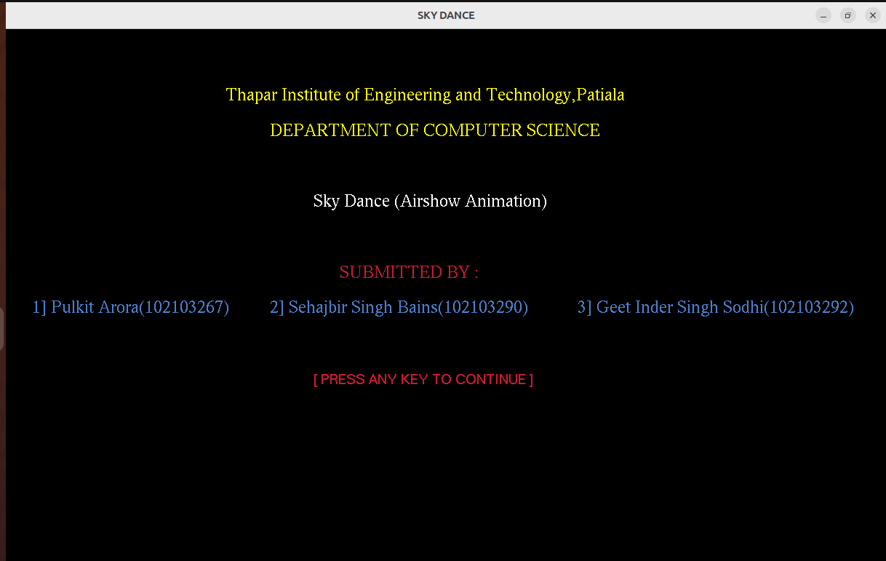

Fig 1

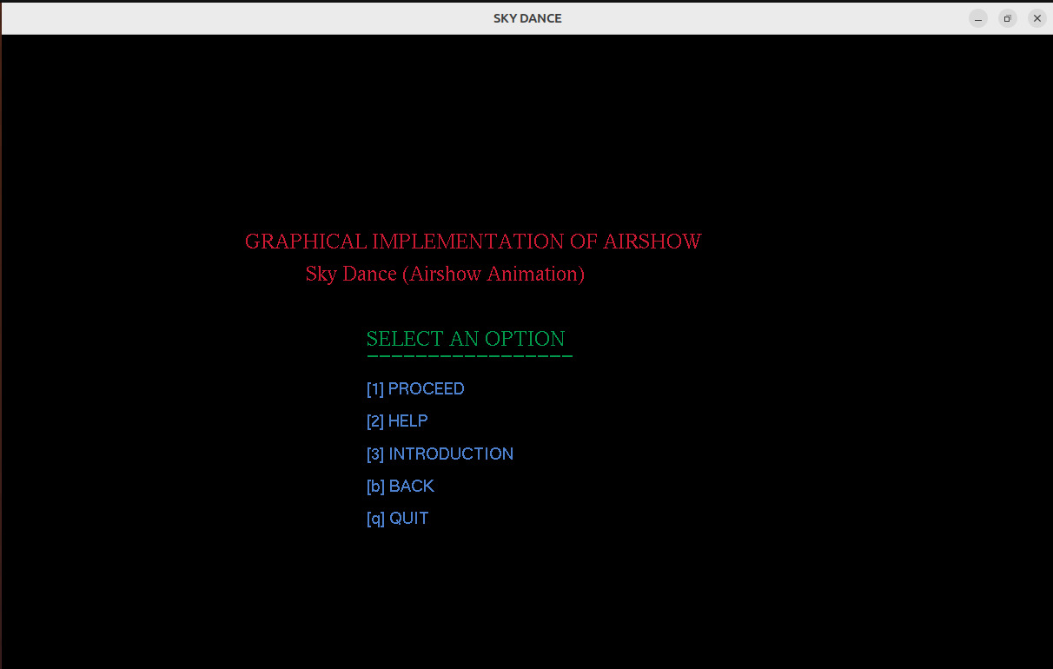

Fig 2

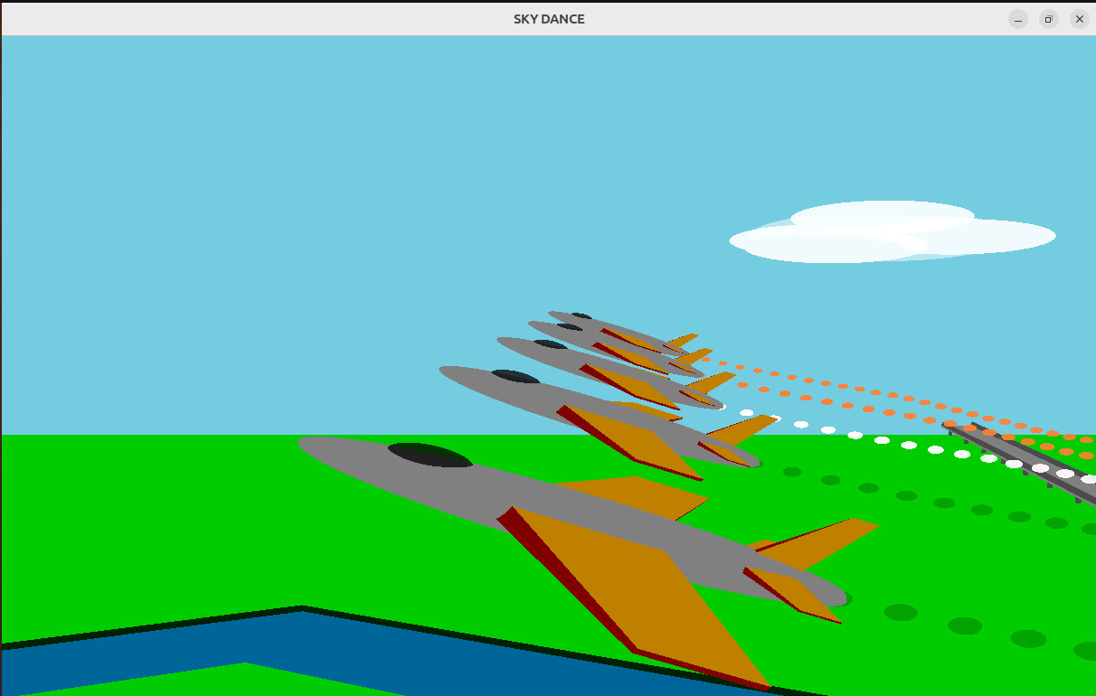

Fig 3

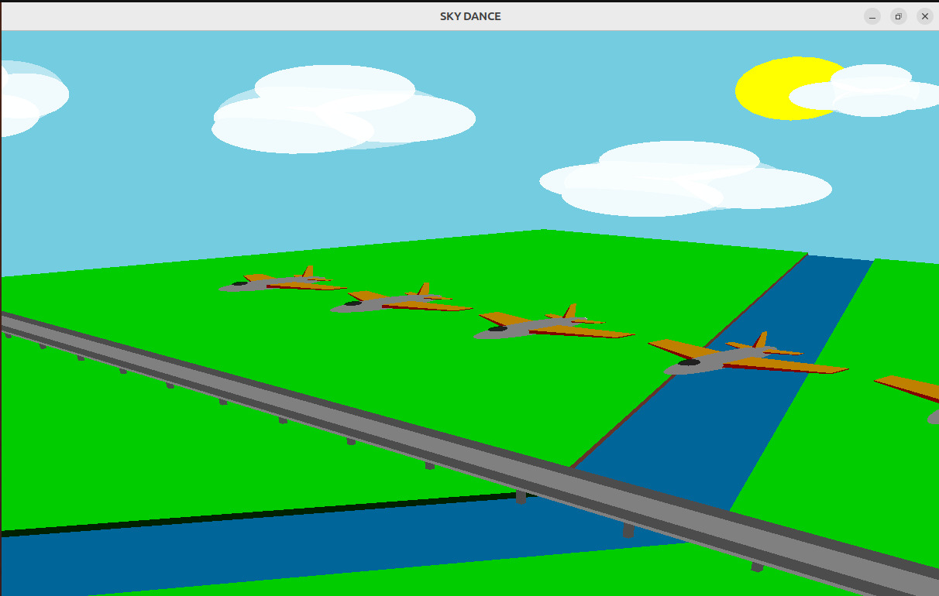

Fig 4

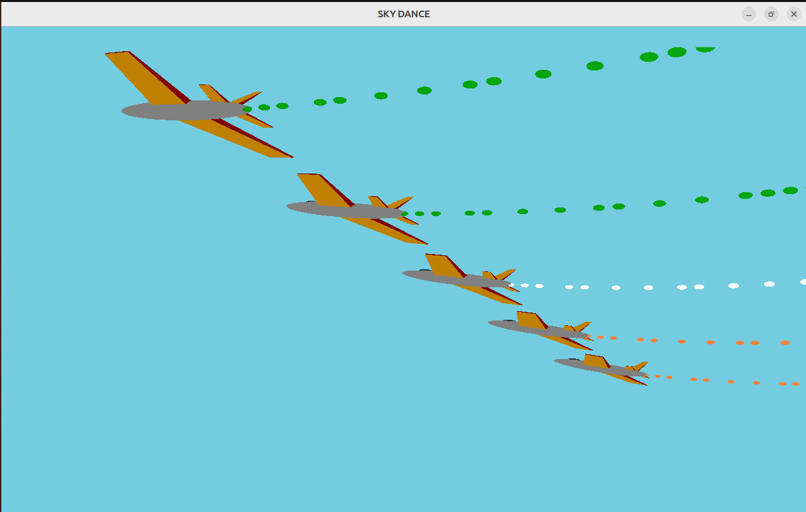

Fig 5

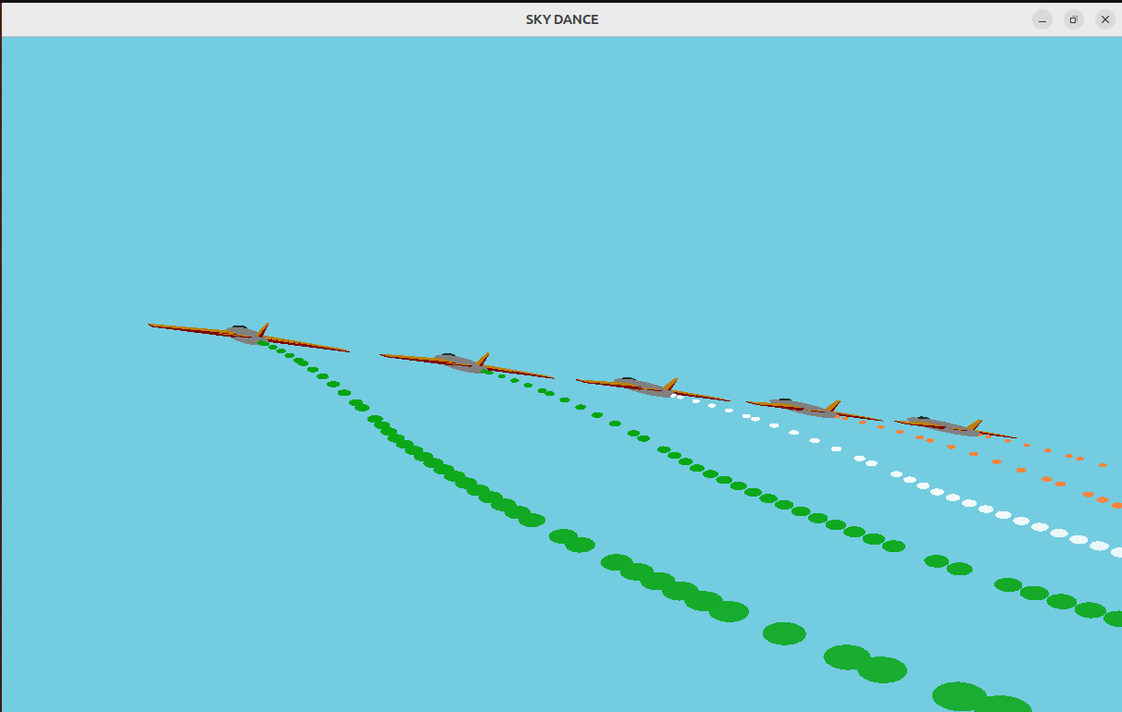

Fig 6

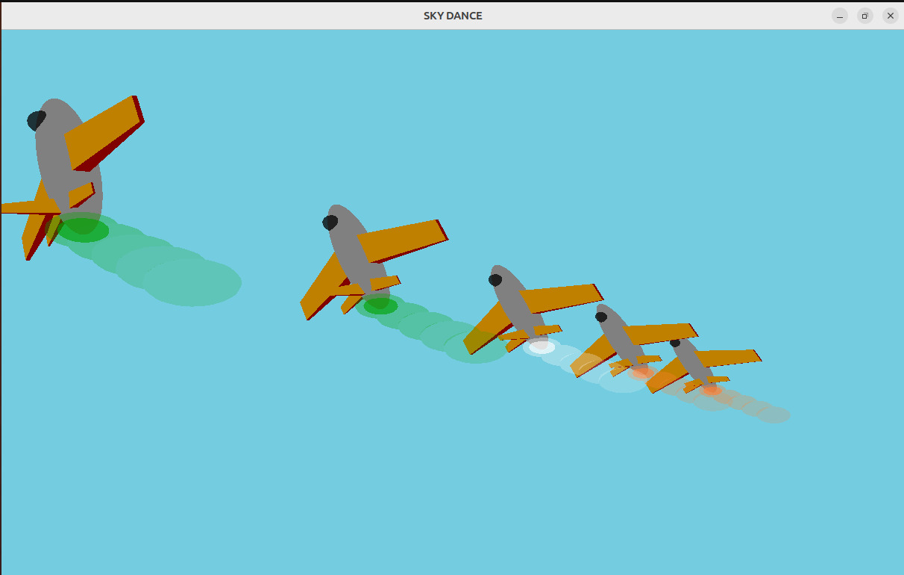

Fig 7